QUESTION #1:

- Discover how many numbers exist (the value of “n”). This will let one know how many numbers should be listed at the end, as well how many need to be sorted.
- Search for the lowest number available, if there are two of the same value, set them both as the lowest number. This will let someone be able to have an easy starting point for sorting.
- Once the first lowest value is found, then search for the second lowest, the third lowest etc. Since the lowest value is being found first and then the higher ones, the result will already be in the desired order
- Print out the found order

Example: 2,4,2,7,9

Step 1: n = 5

Step 2/3:
First lowest: 2 AND 2
Second lowest: 4
Third lowest: 7
Fourth lowest: 9

Step 4:
2, 2, 4, 7, 9

QUESTION #2:
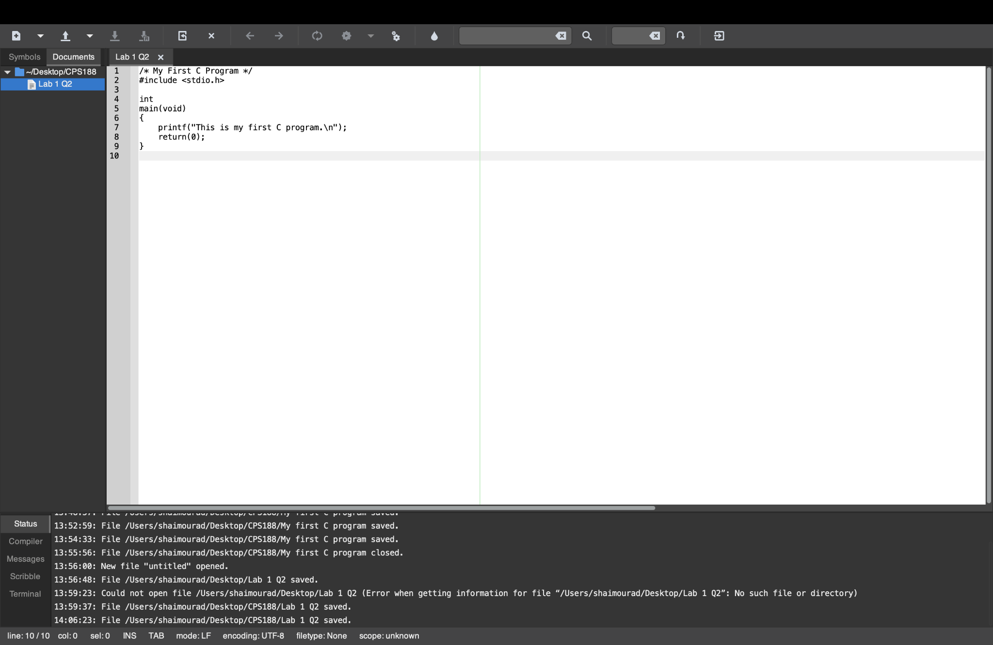

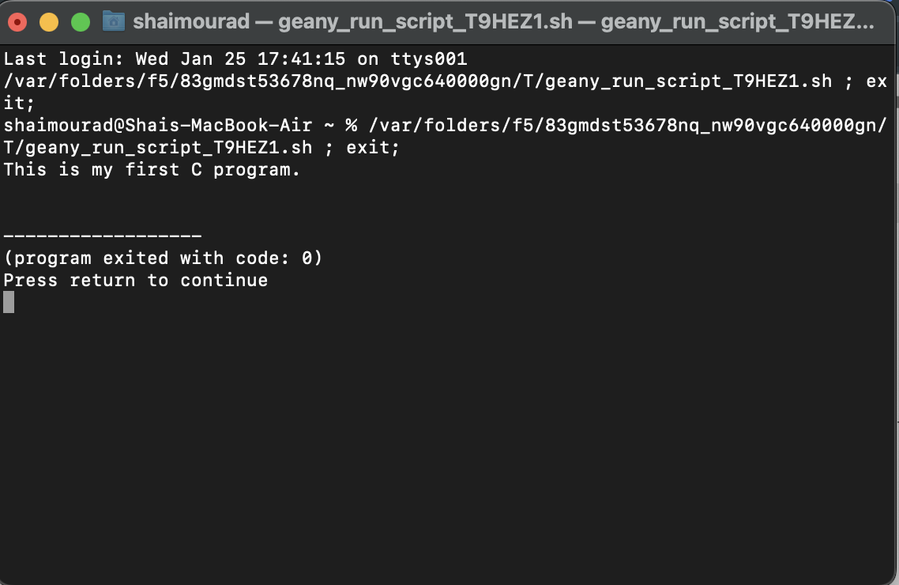

QUESTION #3:
- Ask the user to input the “a” and “b” values
- Create a variable “c” = (a² + b²)^{½}. This uses the pythagorean theorem to solve for the “c” side of the triangle.
- Create a variable “s” = (a*b)/2, for surface area. Finding the area is multiplying the base and height, and then dividing the product by 2.
- Create a variable “p” = a + b + c, for perimeter. Adding all of the sides, a, b, and c, will result in the total length of all sides or in other words the perimeter.
- Print out c, s, and p with two decimal places

